Expensive Restaurant Coupon Acceptance Rates

# Overall Acceptance Rate

The overall acceptance rate was about 44.6% which is lower than the overall acceptance rate and appears to be lower than the other coupon acceptance rates such as coffee shops and cheap restaurants.

# Destination

Individuals who do not have a particular destination in-mind and are not in a rush also show a higher acceptance rate than the overall. Heading to work seems to have the lowest acceptance rate, as these individuals most likely don’t have time to sit down and eat, when they are on their way to work.

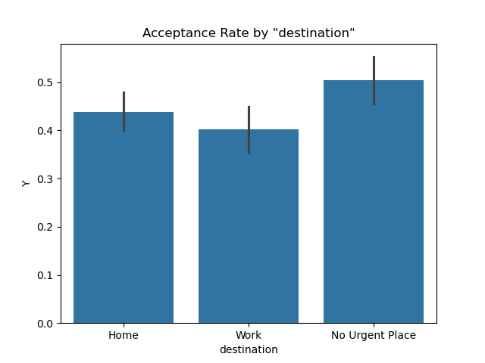

# Passenger

Those riding with those they are close to (friends and significant others) have a higher acceptance rate. Those riding alone have the lowest, which lends to the idea that individuals do not like to sit down and eat alone. Those with children in the car also have a lower rate, probably due to the difficulty of last minute plans for children and the difficulty of dining with children.

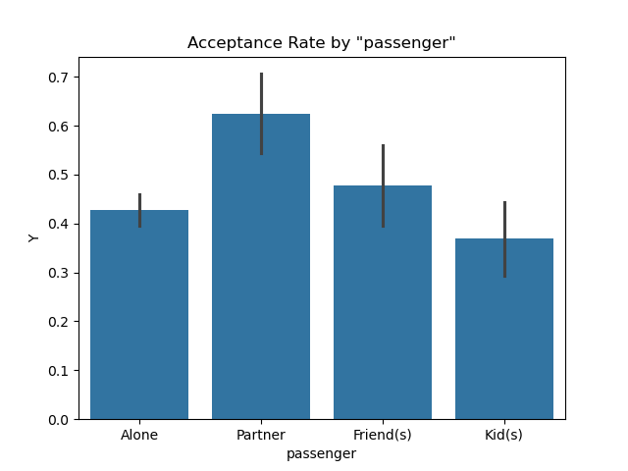

# Weather and Temperature

Days where it is sunny and not raining or snowing show a much higher acceptance rate. This logic continues when we look at temperature. The warmer the day, the higher the acceptance rate. And we know that sunny days are more likely to be hot, so this makes logical sense. In conclusion, when the weather is nice and it feels good outside, individuals seem to accept the coupons more.

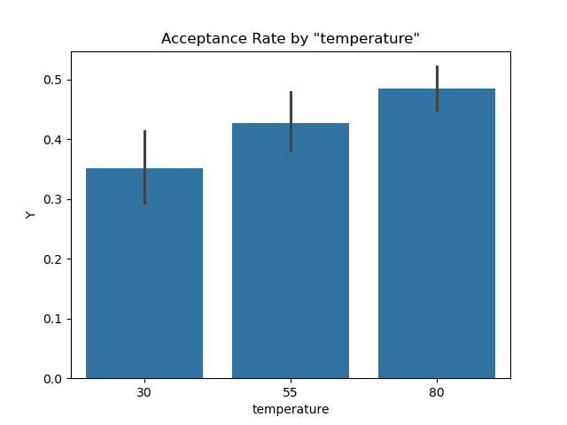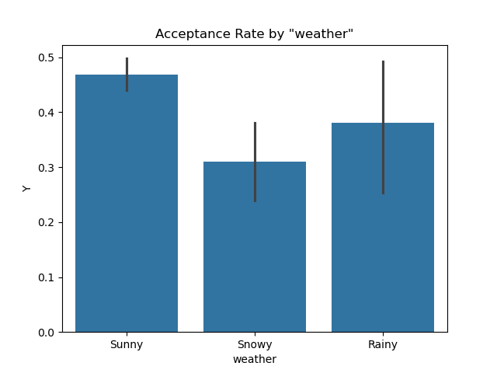

# Time of Day

The highest acceptance rates are for later in the morning and later in the afternoon. Those with the lowest acceptance rates are early in the morning and late at night. This makes me think that those accepting the coupon may have missed breakfast or missed lunch and took the coupon as an opportunity to get food at a reduced price.

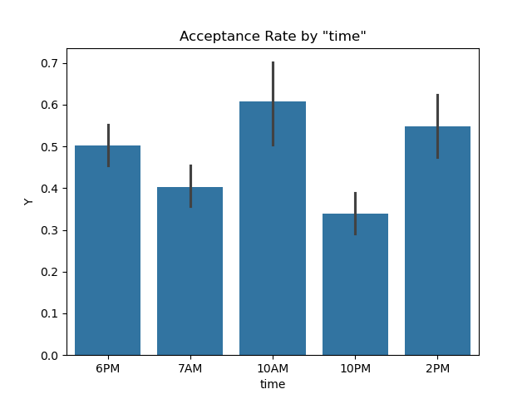

# Expiration Time

When the expiration time is 1 day, the acceptance rate is much higher, compared to shorter expiration times. People like flexibility, and maybe if they see the coupon and don’t have time in the current day, then can make more plans for the following day, when they are not driving around.

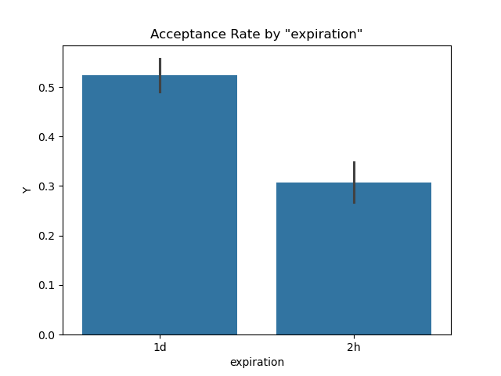

# Gender

Gender really didn’t appear to be a determining factor in whether or not someone accepted the coupon. The rate for women is slightly lower and could be due to confounding variables (having a child with them when they receive the coupon).

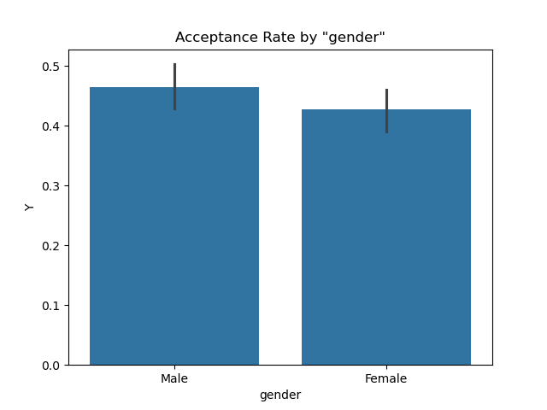

# Income

Finally, there does not seem to be a consistent pattern with the income data, but we can point out two things. Those who have disposable income, appear to be more likely to accept the coupon. However, the $25,000 - $37,499 income bracket also shows a higher acceptance rate than the other groups. This I think deserves some more exploration, but we could hypothesize that those in the 25k to 37k category are working jobs where there is not a lot of time to plan ahead for cooking. Therefore, they may be more likely to eat out, and more likely to treat themselves to a more expensive meal, if there is a coupon,

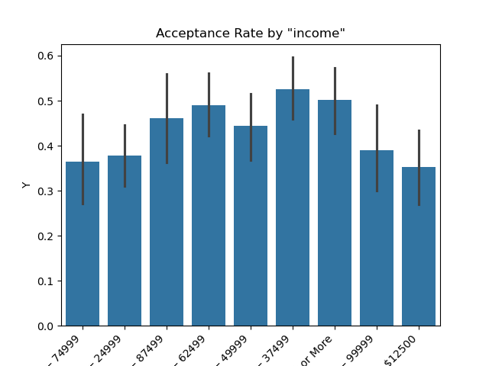

# Age

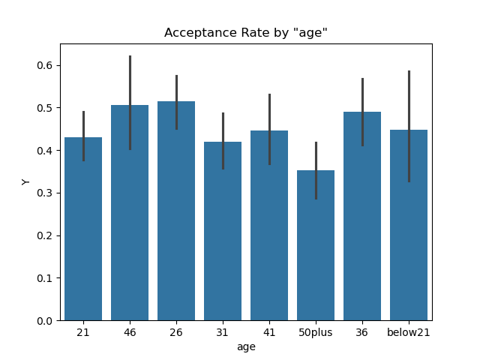

# Group Analysis

To explore these relationships further, I created a few groups to explore.

## Group 1 (Frequent Bar Visitors)

These individuals had an acceptance rate of ~ 48%

## Group 2 (Lower Acceptance Rate)

This group was designed to see if the acceptance rate was lower than the overall. It was, at 42.7%. This group included those heading to work, riding alone, or with a child.

## Group 3 (Frequent Coffee House Visitors)

Acceptance rate for this group was 56% which is in line with the overall acceptance rate for all coupons. This is purely those who go to coffee houses 1 - 3 times a day.

## Group 4 (Combined Frequent Bar Visitors and Coffee House Visitors)

This group also had a higher acceptance rate than the overall group with a 53.3% acceptance rate.

## Group 5 (Expiration Date)

Those who did not have a child with them and received a ticket that expired in a day, had a 55.5% acceptance rate.

# Conclusion

Individuals who are not heading to a particular destination and are not in a rush, go to bars or coffee houses often, and do not have a child with them in the car with them are more likely ro accept coupons for more expensive restaurants.

There are other external factors that also seem to impact the acceptance rates as well. On days with nice weather, these coupon acceptance rates go up. We also see that when coupons are given with at least 1 day before expiration, that there are higher acceptance rates. Finally, age and gender do not appear to be a significant differentiator in acceptance rates.